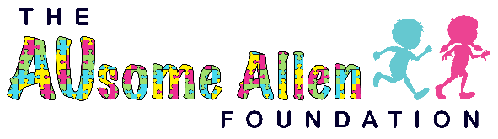
Sign Language Panel
Model #188835
Children and adults of all abilities will have fun learning the American Manual Alphabet with the PlayBooster® Sign Language Panel. This will give all those around the ability to learn sign language to communicate with the deaf heroes. Learning sign language is considered a second language, not only does learning this language benefit you, but it also helps those in need.
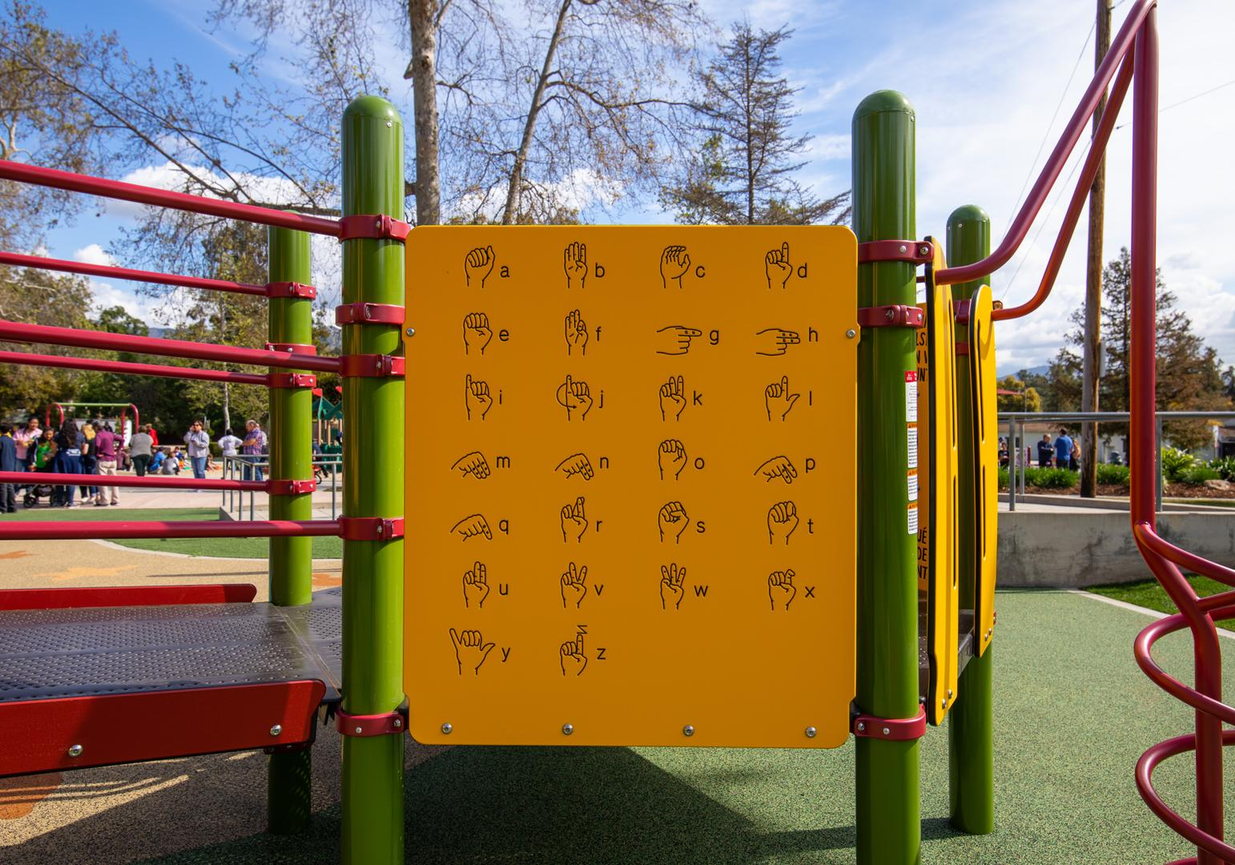

Features of this sign language panel
- Alphabet engraved on both sides of panel.
- Durable 3/4" Permalene material
- 36" W x 41" H
- Ground-level and deck mount
Sensory and Skill benefits
- Proprioception
- Problem Solving
- Strategic Thinking
- Cooperation
- Imaginative Play
- Social Skill Development

- Tactile
- Visual
- Eye-Hand Coordination
- Fine Motor
- Motor Planning
The Ausome Allen foundation would like to have 4 of these throughout the park including the nature trail, allowing for more friendships to be created. These panels can also help families struggling with learning sign language to communicate with their loved ones, providing more love and comfort each time they visit. Each panel will cost $7,000. But there is no price on being able to communicate with someone who can only speak with their hands. To give thanks to our sponsors and donors we will have signs up that say this panel was donated by ……, and we will have sponsor logos on plaques throughout the park and on the puzzle piece walls. There is nothing more Texas than getting outside, playing with your friends, loving life and God.

