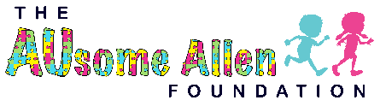
We go Swing Model #277778

This we go swing allows kids and adults of all abilities the chance to enjoy the thrill of swinging together and with others. With there being no need to have to transfer out, this swing opens an entire new world of ausome playtime for these hero’s.
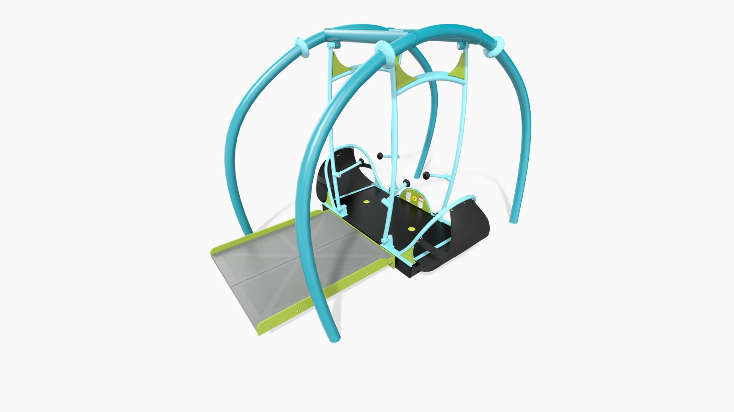

Features of this swing
- Encourages social interaction for a truly inclusive play experience by encouraging multiple users to work together to swing.
- Does not need to be segregated from the play space, surrounded by a fence, or locked when not in use.
- The Handlebars help with the swinging motion, keep users in place and rotate up for easy entrance and exit.
- Comes with 2 accessible bays and one bench seat.
- 60” x 72” entry deck included, to be connected to ramp or other access, for easy roll-on access
- ADA compliant
- Direct bury.
- Max Fall Height (ASTM/CSA/EN): 48” (1,22 m)
- Min Area Required: 26' 1" x 26' 8" (7,95 m x 8,15 m)
Sensory and skill benefits of the swing
- Proprioception
- Tactile
- Vestibular+
- Visual
- Motor Skills
- Agility
- Balance
- Coordination
- Core Body Strength
- Flexibility
- Motor Planning
- Upper Body Strength
- Cognitive Skills
- Problem Solving
- Social/Emotional Skills
- Cooperation
- Imaginative Play
- Social Skill Development

The benefits of this swing can forever change the lives of the special needs hero enjoying it, the parents watching their child smile, all while encouraging others to come play along changing their hearts too. The price of this swing is $52,000 but doesn’t compare to the lives that it will touch. The Ausome Allen Foundation has not chosen colors yet as we are still in the design process, but we know it will go with our Ausome Cutting horse theme. To give thanks to our sponsors and donors we will have signs up that say this Ausome Swing was donated by ……, and we will have sponsor logos on plaque’s throughout the park and on the puzzle piece walls. There is nothing more Texas than getting outside, playing with your friends, loving life and God.
