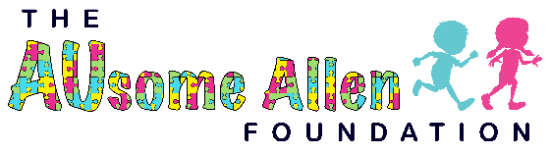

Help us Change the world for special needs of all ages and abilities!!

Throughout the year the Ausome Allen foundation hosts various events to help support individuals with special needs and abilities. Our foundation gives special needs individuals a chance to be a part of a team bigger than their diagnosis and be stronger than their challenges. We want them to know that they are not alone and are covered with love and support within their AUsome Allen family. It is our hope that those individual, affectionately referred to as hero’s, participate in our events. Our foundation’s motto is ability not disability. Our purpose is to raise money to help our heroes and their families live full and happy lives. We take great pride in our growing ability to supply networking, resources, and support for heroes of all ages, abilities and their families. With the help from a variety of doctors we hope to provide emotional and physical support while creating lifelong friendships and trust.
We believe a big part of a successful and fun filled life is physical, emotional, and mental health. This includes having an outlet, such as a place to go where you can play, hang out with friends and family, celebrate, and just be yourself. Somewhere where there is no judgement when a moment is overstimulating for you or your child, smelling the flowers and enjoying nature. We want to create a place for comfort and joy. After all, it’s good for the heart.
To be able to have this opportunity to provide this space for our heroes and their loved ones is the ultimate dream for us! Our AUsome Allen team have hearts big enough to change the world and are eager to do so. To make this ausome build happen, we have partnered with Whirlwix, the builders of The Dream Park in Fort Worth, TX to help build the first of its kind wheelchair accessible treehouse, birthday party rooms, nature trail and so much more. The nature trail will also be made of rubber with our sponsors, and loved ones logos/names inside.
We can say with a happy heart, this will be our first but we know the first of many partnering and participating with my sweet charity of north Texas giving day who help everyone around the glorious state of Texas with all dreams and make them not only reachable but possible. It is a true honor and blessing to have this opportunity to have them stand beside us as we change the world with and for special needs of all ages and abilities. Hand in hand. We know with the help of North Texas Giving day that our foundation will be heard all over and will touch hearts while changing the lives of others and forever impact the life of special needs heroes. The more people we reach the more hearts we touch, the more mountains we move, the more resources we get, the more we are able to help provide short-term and long-term care for these heroes and their families
In addition to the park we hope to continue the original mission of AUsome Allen was to sponsor hero’s to attend a summer camp geared towards those with special needs and abilities being able to have the experience so many hold dear from their childhood. This camp allows them to safely get out of their comfort zone and be encouraged to try new things. These experiences will help hero’s develop skills in areas that will help the keys to a successful life.
Together we will change the world with and for our special needs heroes! To find out more about us and our upcoming events that include special needs heroes and celebrities go to AusomeAllen.com. We are hopeful that you will consider joining or growing group of sponsors, monthly partners, and volunteers.

Thank you,
Erica Howell
Theausomeallen@gmail.com
817-901-8273

