12' Double-Wide Ramp w/Barriers
Model #168111
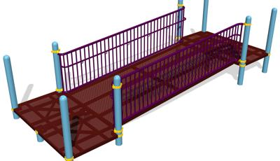
These 12’ wide ramps are the very first step and are imperative in making an accessible park possible, without these ramps you do not have an accessible playground and it limits the access areas for wheelchairs and walkers. The more ramps allocated throughout the play area(s) gives a wider area of exploring for wheelchair heroes. Not only do the ramps allow more room to venture out, or in our case out and up, but they allow room for their chairs and their friends to be with them to explore the world together. These double wide ramps create equitable access for children and grown-up companions of all abilities. While these 12’ double-wide ramp with barrier connect other playground products together it also connects dreams.

Features of the ramp
- 12'-long, 60"-wide ramp attaches at 8" deck increments up to 72" with Barrier.
- Allows for wheelchairs to pass along side others while on the ramp.
- Steel plank
Sensory and skill benefits
- Social Skill Development

- Proprioception
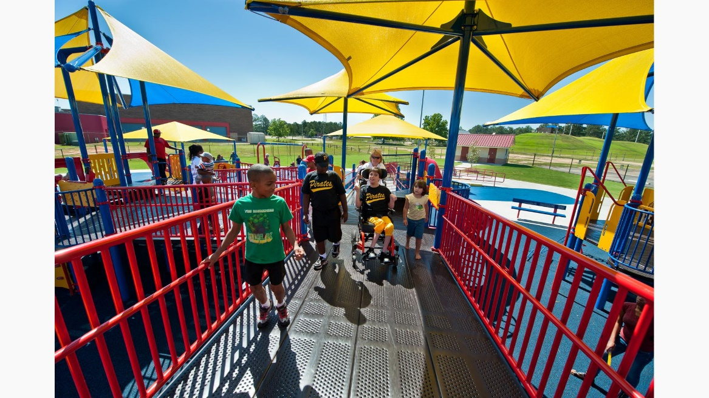
- Tactile
- Vestibular
- Visual
- Problem solving
- Balance
- Coordination
- Core Body Strength
- Lower Body Strength
- Motor Planning
- Cooperation
- Imaginative Play
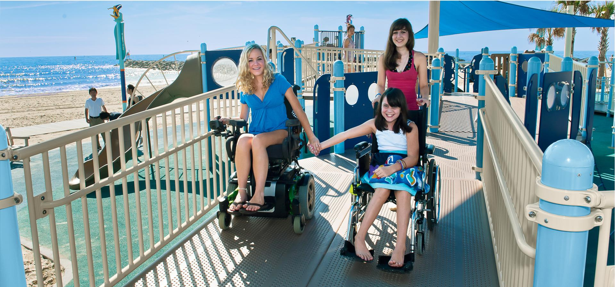

The Ausome Allen foundation needs approximately 22 of these 12’ wide ramps to make our wheelchair accessible treehouse possible at all angles for wheelchairs and walkers. These ramps will benefit these heroes and their families for the rest of their lives giving them a chance to experience things that were out of their reach. Each ramp will cost $17,000. The Ausome Allen Foundation has not chosen colors yet as we are still in the design process, but we know it will go with our Ausome Cutting horse theme. To give thanks to our sponsors and donors we will have signs up that say this ramp was donated by ……, and we will have sponsor logos on plaques throughout the park and on the puzzle piece walls. There is nothing more Texas than getting outside, playing with your friends, loving life and God.

